Korea Institute of Ocean Science and Technology (KIOST) Designated as Independent Laboratory Authorized to Perform US Approval Tests for BWMS

On February 15, 2019, the Korea Institute of Ocean Science and Technology (KIOST, President Kim Woong-seo) was designated as the sixth United States Coast Guard independent laboratory (USCG IL¹), which are authorized to perform US approval tests for ballast water management systems (BWMS²).
- USCG IL (United States Coast Guard independent laboratory): an independent testing agency authorized to conduct performance testing for ballast water treatment systems installed on ships navigating along US coasts on behalf of the US Coast Guard
2) BWMS (ballast water management system): a facility for destroying and discharging biological and pathogenic bacteria in ballast water in accordance with international standards

The International Maritime Organization (IMO) adopted the Ballast Water Management Convention in 2004 to prevent the destruction of marine ecosystems by the transboundary movement of foreign marine life contained in ballast water. Accordingly, ships built after September 2017 are required to install a BWMS that has been approved by the IMO and their respective governments, and ships built prior to 2017 are required install a BWMS between 2019 to 2024.
Apart from the IMO convention, the United States has enacted and implemented a federal law that allows only vessels equipped with BWMS approved by the US Coast Guard to discharge their ballast water in American territorial waters in order to protect the marine environment. This US approval can be issued by independent laboratories (USCG IL) certified by the United States Coast Guard.
It is estimated that about 64,000 ships worldwide will have a BWMS installed by 2024, about 50,000 of which were built before 2017. As a result, the size of the global market for BWMS, based only on the number of vessels requiring BWMS installation by 2024, is estimated to be about KRW 47 trillion.
In order for our BWMS, which makes use of active substances manufactured in Korea, to be approved, the BWMS must gain the approval (G9) of the IMO and then pass a test conducted by a Korean testing agency licensed to issue Korean government approval (G8) in accordance with the IMO guidelines.

* The IMO’s BWMS approvals are divided into G8 approval and G9 approval.
“Active substance” refers to a substance or organism that is used to process harmful aquatic organisms.
G9: an environmental assessment conducted to prevent secondary pollution from active substances
G8: a guideline for approval by the government of each country (and according to which the Korean government certifies government approval)

In 2007, KIOST was designated as the first testing agency in Korea for BWMS approval and carried out tests at a land-based facility and onboard ships to gain government approval (G8) until 2012. Subsequently, with the support of the Ministry of Oceans and Fisheries, KIOST was able to establish its own land-based facility, helping it be designated as a USCG IL in Korea in 2013. Since then, the institute has been playing a leading role, performing quality control for government-approved testing agencies.
Especially in the certification of USCG IL, KIOST was recognized as the only laboratory equipped with onshore and onboard testing personnel and onshore testing facilities as well as a USCG IL responsible for testing for both US and Korean approval.
President Kim Woong-seo said, “As BWMS must be installed on all international ships by 2024, more Korean BWMS companies are expected to apply for the US approval test, and our designation as a USCG IL can resolve any bottlenecks that may arise. KIOST, which has the best BWMS and testing capability in Korea, will cooperate with relevant organizations to solve the difficulties of domestic companies.”
<Contact Information of Our Experts>
Name | Specialty | Telephone No. | E-mail
Jang Pung-guk, Senior Research Scientist | Environmental risk assessment for ballast water | 82-55-639-8514 | pgjang@kiost.ac.kr
Shin Kyoung-soon, Principal Research Scientist | Ballast water and physiological ecology of plankton | 82-55-639-8510 | ksshin@kiost.ac.kr

Reference1 |  | Overview of Ballast Water

□ Ballast Water
ㅇ Water pumped into or out of the ballast water tank to balance a vessel according to the loading condition of the cargo
Cargo unloading and  pumping in of ballast water |  | Navigation of ship without cargo |  | Cargo loading and  ballast water discharge |  | Navigation with cargo
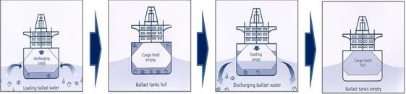
Inflow of marine organisms (Port A) |  | Navigation with ballast water in tank  (offshore) |  | Discharge of ballast water along another coast  (Port B) |  | Navigation without ballast water in tank  (offshore)

□ Background of Fostering the BWMS (Ballast Water Management System) Industry
ㅇ More than five billion tons of ballast water is transported across the oceans and seas annually, along with approximately 7,000 marine species.

Major marine organisms transferred through discharge of ballast water (10 most common species included / defined by IMO )
Cholera Water Flea Crab Toxic algae

ㅇ To prevent ecosystem disturbances, the IMO adopted the Ballast Water Management Convention, which requires the installation of treatment facilities on ships (February 2004).

- Effective as of 2016, the convention applies to ships built since 2017 and will be applied to all other existing ships sequentially from 2019 to 2024.

⇒ For international navigation, vessels must be equipped with a ballast water management system that meets the requirements of the convention from the time the convention enters into force.

Reference 2 |  | Overview of US Approval

□ The US (USCG) Regulation on Ballast Water Management
ㅇ The United States has been enforcing its own regulations mandating the installation of ballast water management systems to protect its marine environment, regardless of the introduction of the Ballast Water Management Convention.
ㅇ Ships entering the United States must be approved by the USCG.

□ Criteria for Ballast Water Discharge
Applicable criteria | Size of microorganisms |  |  | Pathogens and indicator organisms
 | More than 50µm | More than 10µm and  50µm or less | 10µm or less | Toxic vibrio  cholera | Escherichia coli | Enterococcus
IMO Criteria and USCG Level 1 | Less than 10 microorganisms  /m³ | Less than 10 microorganisms  /ml | - | Less than one microorganism  /100 ml | Less than 250 microorganisms  /100 ml | Less than 100 microorganisms  /100 ml
USCG Level 2 | Less than one microorganism  /100 tons | Less than one microorganism  /100ml | Less than 1,000 microorganisms  /100ml | Same as above | Less than 126 microorganisms  /100 ml | Less than 33 microorganisms  /100 ml

* In 2019, we will reconsider the domestic application of the USCG’s two-level criteria.

Reference 3 |  | BWMS (Ballast Water Management System) of KOIST

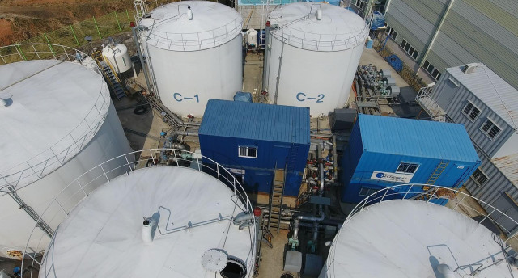
【Photo 1. KIOST’s BWMS 】

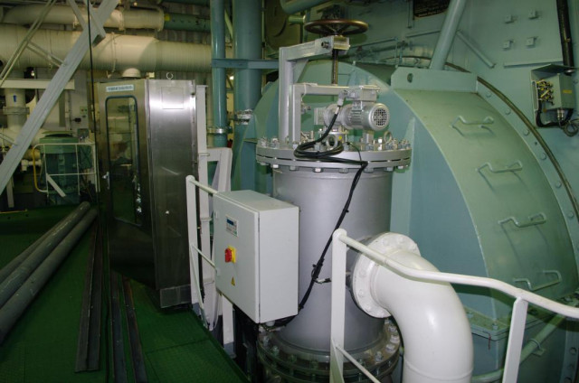
【Photo 2. Ballast water treatment facility installed on a ship】

